Integrating the Healthcare Enterprise



IHE PCC

Technical Framework Supplement

Request for Clinical Guidance (RCG)

Draft for Trial Implementation
July 31, 2009

What is this?
This page is standard language for all IHE supplements. The Introduction section following will list all other IHE documents that are modified by this supplement. This document is a supplement to the IHE Patient Care Coordination Technical Framework 4.0. The technical framework can be found at http://www.ihe.net/Technical_Framework/index.cfm#pcc.
This and all IHE supplements are written as changes to a base document. The base document is normally one or more IHE Final Text documents. Supplements tell a technical editor and the reader how to modify the final text (additions, deletions, changes in wording). In order to understand this supplement, the reader needs to read and understand all of the base documents that are modified by this supplement.
In this supplement you will see “boxed” instructions similar to the following:
Replace Section X.X by the following:
These “boxed” instructions are for the author to indicate to the Volume Editor how to integrate the relevant section(s) into the overall Technical Framework.
This format means the reader has to integrate the base documents and the supplement. When the material in the supplement is considered ready for incorporation into the final text of the Technical Framework, the IHE committees will update the technical framework documents with the final text. Supplements are written in this format to avoid duplication material. This means that two IHE documents (one possibly final text, and the other a supplement) should not contain contradictory material.
Text in this document is not considered final for the Technical Framework. It becomes Final Text only after the IHE PCC Technical Committee ballots the supplement (after testing) and agrees that the material is ready for integration with the existing Technical Framework documents.
It is submitted for Trial Implementation starting August 1, 2009.
Comments on this supplement may be submitted http://forums.rsna.org:
- Select the “IHE” forum
- Select Patient Care Coordination Technical Framework
- Select 2009-2010 Supplements for Public Comment
- Select Immunization Care Plan
Details about IHE may be found at: www.ihe.net
Details about the IHE Patient Care Coordination may be found at: http://www.ihe.net/Domains/index.cfm
Details about the structure of IHE Technical Frameworks and Supplements may be found at: http://www.ihe.net/About/process.cfm and http://www.ihe.net/profiles/index.cfm

Introduction
This supplement is written for Trial Implementation. It is written as changes to the documents listed below. The reader should have already read and understood these documents:
- PCC Technical Framework Volume 1, Revision 4.0
- PCC Technical Framework Volume 2, Revision 4.0
This supplement also references other documents. The reader should have already read and understood these documents:
- HL7 Version 3 Standard: Care Provisions, Release 1
- HL7 and other standards documents referenced in Volume 1 and Volume 2
- Dilbert 2.0: 20 Years of Dilbert by Scott Adams, ISBN-10: 0740777351, ISBN-13: 978-0740777356
This supplement defines the Request for Clinical Guidance (RCG) profile provided for trial implementation.
The Request for Clinical Guidance (RCG) integration profile describes how Clinical Decision Support services can be integrated with healthcare IT systems. It defines a transaction that allows a health care provider to request suggestions for treatment, diagnosis or testing based on individualized patient data. The RCG profile is used with content profiles that describe the individualized patient data that is submitted to the service and the responses that service returns.

Open Issues for Request for Clinical Guidance
- Content in the HL7 Message and Control Act wrappers duplicate capabilities now available in WS-* profiles, how should this overlap be addressed?

Closed issues for Request for Clinical Guidance
- The Request for Clinical Guidance needs to be able to limit the diseases or disease families, either by inclusion (i.e., provide RCG just for influenza), or by exclusion (i.e., provide RCG for all but influenza and pneumonia). Can we keep this out of the payload, and specify it as part of the web service operation?
This is included in the payload, and not as part of the web service operation.
- Addressing the issues of feedback, given that these choices were provided, getting feedback upon what choice was selected (if any) is important to the decision support process (c.f., Machine learning). What mechanism should be provided to allow feedback to be given?
This was determined to be out of scope for this year.
- Previously defined IHE PCC Content profiles for Immunization Content (IC) will be used for both the “Request for Clinical Guidance” and the response. In the response, IC will express the “validated history” as well as the “immunization care plan”.
- Is the profile dealing with just synchronous queries (question/answer style), or will it also deal with asynchronous issues as well (stateless vs. statefull).
This profile deals with just synchronous stateless queries. Asynchronous statefull clinical decision support is enabled by the Care Management profile.
- Is there a way to address stateless/statefull above using composition, and if so, what actor deals with maintenance of state between invocations?
There is a way to address statefull decision support using composition with the care management actor and the clinical data source. The maintenance of state information depends upon the clinical decision support algorithm and is outside the scope of this profile.
- Is the latter an issue to be addressed in ITI in a subsequent iteration?
Possibly, but not at this time.
- Inclusion of HL7 v2 content in the Request for Clinical Guidance, and its response needs to be further defined. E.g., will it be piped v2 messages, contained within a CDATA xml element, or will it follow the v2 XML naming conventions and structure? Which specific v2 messages will be supported? We might want to use VXU and VXR messages for the time being, structured according to the CDC / AIRA Implementation Guide for Immunization Registries. This needs to be harmonized with the current effort to update this Implementation Guide.
The RCG-IC will support IC content in the RCG in only Care Record format and will not support Version 2 messages.
TABLE OF CONTENTS

IHE PCC 0
Technical Framework Supplement 0
What is this? 1
Introduction 2
Open Issues for Request for Clinical Guidance 2
Closed issues for Request for Clinical Guidance 2
Volume 1 – Integration Profiles 5
Glossary 5
2.5 Dependencies among Integration Profiles 5
2.7 History of Annual Changes 5
X Request for Clinical Guidance Integration Profile 6
X.2 Actors and Transactions 7
X.3 Options 7
X.4 Grouping 8
X.4.1 Consistent Time 8
X.4.2 Audit Trail and Node Authentication 8
X.4.3 Content Integration Profiles 8
X.5 Request for Clinical Guidance Process Flow 8
X.5.1 Immunization Forecasting 8
X.5.2 Drug Safety 10
X.5.3 Identifying Qualifying Patients 10
X.6 Request for Clinical Guidance Security Considerations 10
Volume 2 - Transactions 11
3.12 Request for Clinical Guidance 11
3.12.1 Use Case Roles 11
3.12.2 Referenced Standards 12
3.12.3 Interaction Diagrams 12
3.12.4 Report Care Provision 12
3.12.5 Application Acknowledgement 15
3.12.6 Security Considerations 20
Appendix F - Transforming CDA Documents to Care Record Messages 21
F.1 Mapping the CDA Header to the Care Record Message 22
F.2 Mapping the CDA Body to the Care Record Message 23
F.2.1 What happens to section.text 23
F.3 Mapping CDA Entries to clinical statements in the Care Record 24

Volume 1 – Integration Profiles

Glossary
Add the following terms to the Glossary:
Clinical Decision Support (CDS) – The ability to use data to discover and/or justify the proper activities planned for a patient.
Decision Support Service – DSS is Decision Support provided as a computerized web service. It is a basic component of Service Oriented Architecture (SOA) for Healthcare. When it is used to provide Clinical Decision Support, it is often called a CDS Service, or simply CDSS.

2.5 Dependencies among Integration Profiles
Add the following to the Table in Section 2.5

Integration Profile | Dependency | Dependency Type | Purpose
Request for Clinical Guidance (RCG) | Consistent Time (CT) | The Care Manager and Clinical Decision Advisor actors shall implement the Time Client actor of the Consistent Time (CT) profile. | Supports the synchronization of time stamps in information generated between the two systems.

2.7 History of Annual Changes
Add the following bullet to the end of the bullet list in Section 2.7
In the 2009-2010 cycle of the Patient Care Coordination Initiative, the following integration profiles were added to the technical framework.
- Added the Request for Clinical Guidance (RCG) Profile that supports the integration of clinical decision support services into healthcare IT systems.

Add Section X below to to the end of Volume I preceding the Appendixes and Glossary

X Request for Clinical Guidance Integration Profile
The Request for Clinical Guidance Profile (RCG) supports integration of Clinical Decision Support into healthcare IT systems. A wide variety of these systems often need access to clinical guidance, for example, when ordering medications, determining appropriate immunizations, diagnostic tests, et cetera. This profile makes it possible for systems to obtain this guidance from within an enterprise.
Within healthcare a broad class of problems are in the area of clinical decision support. Integration of these capabilities into healthcare IT systems has been slow for a variety of reasons. Most of the attention on standards for integration of clinical decision support into applications has been in the area of describing the logic used to solve the problem. However, exchange of decision support algorithms has failed to make decision support more readily available. In part this is due to the wide variety of clinical decision algorithms that may be used to solve a problem. Some problems may be amenable to rule-based logic (e.g., immunization forecasting), others might use complex formulas (weight based dosing regimes), and others may use databases of medical knowledge (e.g., medication interaction checking). No single approach fits all decision support needs. Rather than specify the language in which clinical decision support rules are expressed, this profile describes how to exchange patient data as the payload needed to drive the clinical decision support service.
In this profile we show a uniform way to integrate clinical decision support services into healthcare IT applications to provide solutions to individualized patient care decisions such as:
- Drug and Allergy interaction detection
- Forecasting a vaccine schedule
- Identifying eligible patients for research or other programs
- Cost effective selection of antibiotics based on recent institutional data
The use of these services can be triggered in the healthcare IT system automatically or by user request.
The RCG profile leverages the existing content modules defined previously in the PCC Technical Framework to deliver information needed to a clinical decision support service. The clinical decision support service responds with a suggested care plan or additional clinical information.
The care plan may propose additional observations and assessments to be made to provide more complete analysis, suggest treatment options or contraindications, or additional testing to be performed or avoided. Additional clinical information may be provided to suggest diagnoses or evaluate effectiveness or quality of care (e.g., effectiveness of vaccinations based on prior history and existing or new guidelines or information).
We have noted that there are benefits to saving the responses of clinical decision support requests, and capturing whether the supplied guidance was accepted or rejected or otherwise modified, but this is out of scope for this supplement. We have placed this on our roadmap for future review.

X.2 Actors and Transactions
Figure X.2-1 shows the actors directly involved in the Immunization Care Plan Integration Profile and the relevant transactions between them.
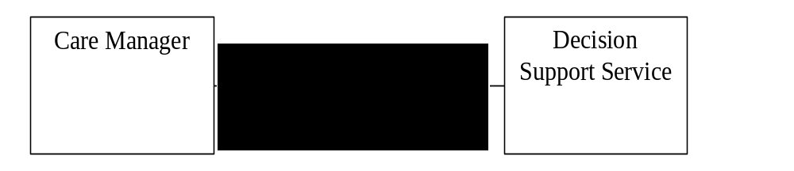
Figure X.2-1 Request for Clinical Guidance Actors and Transactions
The table below lists the transactions for each actor directly involved in the Request for Clinical Guidance Profile. In order to claim support of this Integration Profile, an implementation must perform the required transactions.

Table X.2-1 Request for Clinical Guidance Actors and Transactions
Actor | Name | Optionality | Transaction | Section in Vol 2
Care Manager | Request for Clinical Guidance | R | PCC-12 | PCC TF-2:3.12 Request for Clinical Guidance
Decision Support Service | Request for Clinical Guidance | R | PCC-12 | PCC TF-2:3.12 Request for Clinical Guidance

X.3 Options
There are no options defined for this profile.

X.4 Grouping

X.4.1 Consistent Time
These actors shall implement Time Client actor of the Consistent Time Profile defined in ITI TF-1:7 to ensure that consistent time is maintained across systems.

X.4.2 Audit Trail and Node AuthenticationError: Reference source not found
Actors of this profile may be grouped with either the Secure Node or the Secure Application actor of the Audit Trail and Node Authentication Profile defined in ITI TF-1:9 to ensure the security of the information being exchanged.

X.4.3 Content Integration Profiles
The Care Manager and Decision Support Service actors must be used with content profiles describing the payloads that are used in the request and response messages of the Request for Clinical Guidance transaction. The Immunization Care Plan (ICP) profile is one such profile that can be used with these actors. We anticipate that PCC and other IHE domains will create additional content profiles in the future that work with these actors. Furthermore, we encourage other organizations to develop and share clinical decision support content profiles that work with these actors.
Appendix F Transforming CDA Documents to Care Record Messages describes the model by which a CDA document found in IHE profiles or elsewhere can be transformed to the Care Record message used in the Request for Clinical Guidance transaction. IHE will use this appendix when developing clinical decision support profiles from new or existing CDA based documents. We strongly recommend use of this appendix to others considering a similar approach.

X.5 Request for Clinical Guidance Process Flow

X.5.1 Immunization Forecasting
An EMR provides patient age (adjusted if necessary for premature birth), gender, and current immunization status, allergies and problem information to an immunization forecasting service. The forecasting service responds with evaluations of the immunizations and one or more immunization schedules. The EMR presents the immunization schedule to the end user, who then incorporates one of the suggested schedules into the patient's care plan.
This specific use is further profiled in the IHE Immunization Content Profile (IC) supplement to the PCC Technical Framework. This supplement can be downloaded from http://www.ihe.net/Technical_Framework/index.cfm#PCC.
The process flow for this use case is shown below.
In this process flow, the content creator and content consumer actors are grouped with the Care Manager and Decision Support Actors of the Request for Clinical Guidance Profile.
- A Care Manager Actor acquires the relevant medical information for a patient.
- The Care Manager Actor submits the relevant portions of this information to the Decision Support Service using PCC-12 Request for Clinical Guideance Transaction.
- The Decision Support Service processes the result and returns a response to the Care Manager actor in that same transaction.
- The Care manager then applies the return information. How this information is used by the care manager is out of scope of this profile.
This process flow is shown below in figure X.5-1.
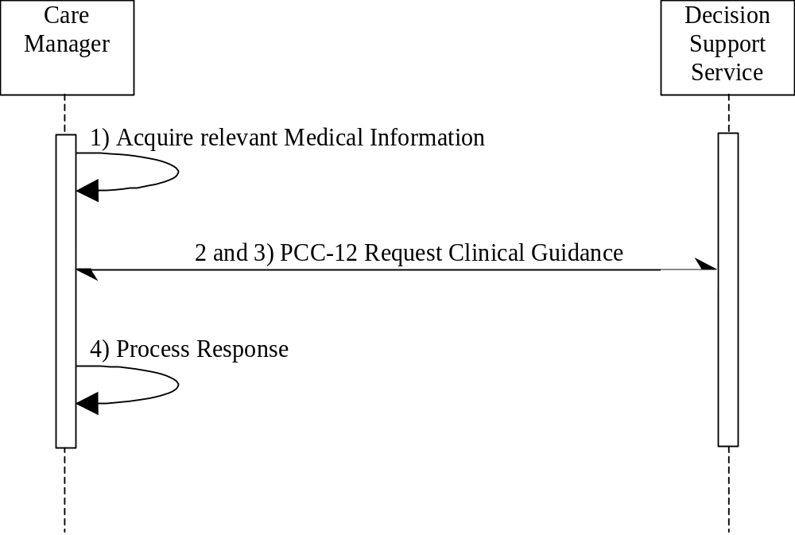
Figure X.5-1 Process Flow

X.5.2 Drug Safety
When a medication is to be administered an EMR provides the patient's current height, weight, age, problems, medications and allergies to a decision support system, along with proposed medication orders. The decision support system responds with alerts or suggested alternative treatments based on possible medication interactions, allergies, failed therapies or even cost. The EMR can then offer these suggestions to the end user prior to completion of the order.

X.5.3 Identifying Qualifying Patients
Upon completion of a visit, the EMR activates a decision support system passing the current patient diagnoses. Upon determining that the patient has been diagnosed with Diabetes, the decision support system notifies the EMR that it should suggest protocols for diabetic care.

X.6 Request for Clinical Guidance Security Considerations
The Request for Clinical Guidance may exchange personally identifiable health information between different systems using web services. For many decision support applications the specific patient identity need not be exchanged to take advantage of these services. Eliminating patient identity information is often not sufficient to obscure the patient identity and should not be relied upon to mitigate risks of exposure. For example, communicating birth date and gender may be enough to identify large groups of people even in a densely populated urban area.
Therefore, these exchanges of health information need to be secured. One mechanism is to use the ATNA profile found in the IHE IT Infrastructure Technical Framework (see http://www.ihe.net/Technical_Framework/index.cfm#IT) to secure the communications. IHE further recommends careful evaluation of the required information to ensure that only relevant information is communicated between the two systems (e.g., communicating age instead of birth date when age is sufficient for the decision support application).
Add the following to Appendix A Actor Summary Definitions
Decision Support Service – A decision support service uses world knowledge, algorithms and individual instance data to generate new knowledge that will facilitate clinical decision-making.
Add the following to Appendix B Transaction Summary Definitions
Request for Clinical Guidance – The request for clinical guidance transaction enables a health IT system to provide clinical data and proposed care actions to a decision support service that can evaluate and suggest additional testing or treatment to provide effective care.

Volume 2 - Transactions
Add Section 3.12 to Volume II

3.12 Request for Clinical Guidance
This section corresponds to the PCC-12 transaction of the IHE Technical Framework. This transaction is used by the Care Manager and Decision Support Service actors found in the RCG profile.

3.12.1 Use Case Roles
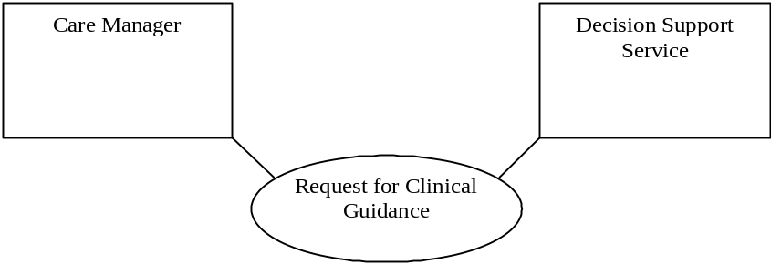

Actor: Care Manager
Role: Sends clinical data, care plans and proposed treatments to the Decision support service to request clinical guidance with an immediate response as an application acknowledgement.
Corresponding HL7 Application Roles:
Care Provision Reporter (REPC_AR004014UV01)
Request Message Sender with App Acks (Immediate) (MCCI_AR000005UV01)

Actor: Decision Support Service
Role: Evaluations clinical data, care plans and proposed treatments in response to a request for clinical guidance. Responds with suggestions for additional observations, care plans or treatments that may be performed for the patient in the application acknowledgement.
Corresponding HL7 Application Roles:
Care Provision Reporting Receiver (REPC_AR004024UV01)
Request Rcvr w/ App Ack (Immed) (MCCI_AR000006UV01)

3.12.2 Referenced Standards
CareRecord | HL7 Care Provision Care Record (DSTU)
HL7WS | HL7 Version 3 Standard: Transport Specification - Web Services Profile, Release
SOAP12 | Simple Object Access Protocol Version 1.2 (SOAP 1.2)

3.12.3 Interaction Diagrams
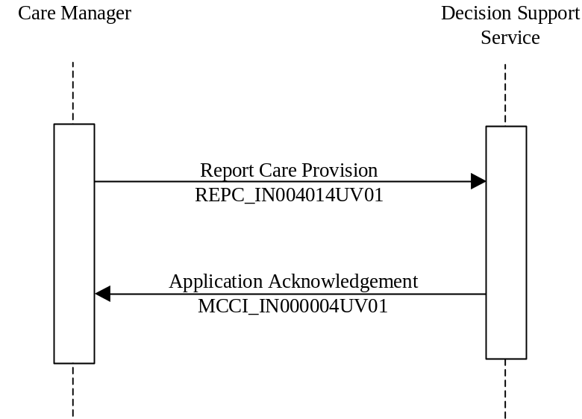

3.12.4 Report Care Provision
The report care provision message is sent from the Care Manager Actor to the Decision Support Service Actor to indicate a care event needing clinical guidance.

3.12.4.1 Trigger Events
This message is triggered by a user action that initiates a request for clinical guidance. This cooresponds to the HL7 trigger event: REPC_TE004014UV01.

3.12.4.2 Message Semantics
The Report Care Provision corresponds to the HL7 Interaction REPC_IN004014UV01, which reports the care provided to a patient. In the context of the Request for Clinical Guidance profile, this includes the care acts that are relevant for computation of the clinical guidance being requested. A schema for this interaction can be found at: http://www.hl7.org/v3ballot/html/processable/multicacheschemas/REPC_IN004014UV01.htm
This schema includes:
- The transmission wrapper MCCI_MT000100UV01
- The control act wrapper MFMI_MT700702UV01, and
- The message payload REPC_MT004000UV01.
These components of the interaction are specified in the HL7 standards described above.

3.12.4.3 Transmission Wrapper
The transmission wrapper MCCI_MT000100UV01 provides information about the message transmission and routing. Transmission wrappers are further described in ITI TF-2: Appendix O.
An example transmission wrapper is given below for this interaction. Items marked in dark gray are transmitted as specified in ITI TF-2: Appendix O. Items in bold black text are further constrained by this profile in this interaction.

<REPC_IN004014UV01 xmlns="urn:hl7-org:v3" ITSVersion="XML_1.0"
xmlns:xsi="http://www.w3.org/2001/XMLSchema-instance">
<id root=' ' extension=' '/>
<creationTime value=' '/>
<interactionId extension='REPC_IN004014UV01' root='2.16.840.1.113883.5'/>
<processingCode code='D|P|T'/>
<processingModeCode code='T'/>
<acceptAckCode code='AL'/>
<receiver typeCode="RCV">
<device determinerCode="INSTANCE">
<id/>
<name/>
<telecom value=' ' />
<manufacturerModelName/>
<softwareName/>
</device>
</receiver>
<sender typeCode="SND">
<device determinerCode="INSTANCE">
<id/>
<name/>
<telecom value=' ' />
<manufacturerModelName/>
<softwareName/>
</device>
</sender>
<controlActProcess>
See Control Act Wrapper below
</controlActProcess>
</REPC_IN004014UV01>

3.12.4.3.1 <REPC_IN004014UV01 xmlns="urn:hl7-org:v3" ITSVersion="XML_1.0"
xmlns:xsi="http://www.w3.org/2001/XMLSchema-instance">
The HL7 Interaction being sent will control the name of the root element in the message. The namespace of this message shall be urn:hl7-org:v3, and the ITSVersion attribute shall be "XML_1.0".

3.12.4.3.2 <interactionId extension='REPC_IN004014UV01'
root='2.16.840.1.113883.5'/>
The identifer for the interaction shall be sent as shown above.

3.12.4.3.3 <processingModeCode code='T'/>
The processingModeCode distinguishes the type of processing being performed. This element shall be present and have the value shown above to indicate that this message is for current processing.

3.12.4.3.4 <acceptAckCode code='AL'/>
The acceptAckCode indicates whether the reciever wants to recieve an acknowledgement, and shall be sent as shown above. This transaction requires an application acknowledgement.

3.12.4.4 Control Act Wrapper
The control act wrapper MFMI_MT700702UV01 provides information about the business actors related to the transaction, including the author or performer of the act. Control act wrappers are further described in ITI TF-2: Appendix O. An example control act wrapper is given below for this interaction. Items marked in dark gray are transmitted as specified in ITI TF-2: Appendix O. Items in bold black text are further constrained by this profile in this interaction, and must appear as shown in the example below.

<controlActProcess moodCode="EVN">
<id root=' ' extension=' '/>
<code code='REPC_TE004014UV01'/>
<effectiveTime value=' '/>
<languageCode code=' '/>
<authorOrPerformer typeCode=' '></authorOrPerformer>
<subject typeCode='SUBJ' contextCondutionInd='false'>
<registrationEvent classCode='REG' moodCode='EVN'>
<statusCode code='active'/>
<subject2 typeCode='SUBJ' contextCondutionInd='false'>
<careProvisionEvent>
See Care Provision Event below
</careProvisionEvent>
</subject2>
</registrationEvent>
</subject>
</controlActProcess>

3.12.4.4.1 <code code='REPC_TE004014UV01'/>
The code element identifies the trigger event. The trigger event for this act is the report of care provision. This element shall be transmitted as shown above.

3.12.4.5 Care Provision Event
The <subject2> element of the <controlActProcess> element above carries the clinical data, care plans and proposals for care that are the subject of the request for clinical guidance. This content must be defined for a clinical decision support request. The Immunization Care Plan profile provides one example of a decision support request in the Immunization Care Plan Request content module.

3.12.5 Application Acknowledgement
The application acknowledgement message is sent from the Decision Support Service Actor to the Care Manager Actor to respond to the request for clinical guidance. The response contains the original clinical data sent in the request for clinical guidance along with the clinical guidance provided by the Decision Support Service Actor.

3.12.5.1 Trigger Events
The trigger event for this message is the receipt of a Report Care Provision event. This cooresponds to the HL7 trigger event: MCCI_TE000003UV01.

3.12.5.2 Message Semantics
The Application Acknowledgement corresponds to the HL7 Interaction MCCI_IN000004UV01. An application acknowledgement includes the response to the initiating message from the receiver, along with the domain content that was acknowledged. The message itself is very similar to the message sent by the Care Manager Actor to the Clinical Decision Support Service actor. A list of the specific changes are identified in sections 3.12.5.3 Transmission Wrapper 3.12.5.4 Control Act Wrapper below.
Note: A schema for this message will be published at the same time as the trial implementation of this specification. We are interested in receiving comments about this use of the HL7 Transmission Structure messages with application acknowledgements.

3.12.5.3 Transmission Wrapper
The transmission wrapper MCCI_IN000003UV01 provides information about the message transmission and routing. Transmission wrappers are further described in ITI TF-2: Appendix O.
An example transmission wrapper is given below for this interaction. Items marked in dark gray are transmitted as specified in ITI TF-2: Appendix O. Items in bold black text are further constrained by this profile in this interaction. This message wrapper is similar to the transmission wrapper used for the inbound message described in section 3.12.4.3 Transmission Wrapper under 3.12.4 Report Care Provision above.

<REPC_IN004014UV01 xmlns="urn:hl7-org:v3" ITSVersion="XML_1.0"
xmlns:xsi="http://www.w3.org/2001/XMLSchema-instance">
<id root=' ' extension=' '/>
<creationTime value=' '/>
<interactionId extension='MCCI_IN000004UV01' root='2.16.840.1.113883.5'/>
<processingCode code='D|P|T'/>
<processingModeCode code='T'/>
<acceptAckCode code='NE'/>
<receiver typeCode="RCV">
<device determinerCode="INSTANCE">
<id/>
<name/>
<telecom value=' ' />
<manufacturerModelName/>
<softwareName/>
</device>
</receiver>
<sender typeCode="SND">
<device determinerCode="INSTANCE">
<id/>
<name/>
<telecom value=' ' />
<manufacturerModelName/>
<softwareName/>
</device>
</sender>
<controlActProcess>
See Control Act Wrapper below
</controlActProcess>
</REPC_IN004014UV01>
Note: This application acknowledgement does not require the optional <acknowledgement> element. This information is redundant when acknowledgements are sent in an immediate response.

3.12.5.3.1 <REPC_IN004014UV01 xmlns="urn:hl7-org:v3"
ITSVersion="XML_1.0" >
The message element name shall be REPC_IN004014UV01 as described above.
Note: Please comment on whether the message element name should be REPC_IN004014UV01 or MCCI_IN000004UV01. The relevant HL7 domain content does not specify interactions for acknowledgements. One benefit to use of the REPC_IN004014UV01 interaction as is done above is that the same message schema is used for the request and response messages.

3.12.5.3.2 <interactionId extension='MCCI_IN000004UV01' root='2.16.840.1.113883.5'/>
The interactionId element identifies the unique information exchange and shall be transmitted as shown above.
Note: Please comment on whether the extension attribute should be MCCI_IN000004UV01 or REPC_IN004014UV01. Even though the schemas for these messages are the same, the interaction (response vs. request) is different. One benefit for the use of the MCCI_IN000004UV01 interaction would be to distinguish between the report of care provision and the application acknowledgement.

3.12.5.3.3 <processingModeCode code='T'/>
The processingModeCode distinguishes the type of processing being performed. This element shall be present and have the value shown above to indicate that this message is for current processing.

3.12.5.3.4 <acceptAckCode code='NE'/>
The application acknowledgement response shall not require a separate acknowledgement.

3.12.5.4 Control Act Wrapper
The control act wrapper provides information about the business actors related to the transaction, including the author or performer of the act. Control act wrappers are further described in ITI TF-2: Appendix O. An example control act wrapper is given below for this interaction. Items marked in dark gray are transmitted as specified in ITI TF-2: Appendix O. Items in bold black text are further constrained by this profile in this interaction, and must appear as shown in the example below.

<controlActProcess moodCode="EVN">
<id root=' ' extension=' '/>
<code code='MCCI_TE000003UV01'/>
<effectiveTime value=' '/>
<languageCode code=' '/>
<authorOrPerformer typeCode=' '></authorOrPerformer>
<subject typeCode='SUBJ' contextCondutionInd='false'>
<registrationEvent classCode='REG' moodCode='EVN'>
<statusCode code='active'/>
<subject2 typeCode='SUBJ' contextCondutionInd='false'>
<careProvisionEvent>
See Care Provision Event below
</careProvisionEvent>
</subject2>
</registrationEvent>
</subject>
</controlActProcess>

3.12.5.4.1 <code code=' MCCI_TE000003UV01'/>
The code element identifies the trigger event. The trigger event for this act is the sending of the application acknowledgement. This element shall be transmitted as shown above.

3.12.5.5 Care Provision Event
The <subject2> element of the <controlActProcess> element above carries the clinical data, care plans and proposals for care that are the response to the request for clinical guidance. This content must be defined for a clinical decision support response. The Immunization Care Plan profile provides one example of the response to a decision support request in the Immunization Care Plan Response content module.

3.12.5.6 Expected Actions – Care Manager
The Care Manager sends the Request for Clinical Guidance as specified above and waits for a response from the Decision Support Service.

3.12.5.7 Expected Actions – Decision Support Service
The Decision Support Service processes the data given in the request. The Decision Support Service shall respond with an application acknowledgement. The application acknowledgement will contain the original payload data, and may provide additional clinical statements, care plans, proposals for care and optional references to applicable guidelines or protocols. This additional data is the result of the clinical decision support service request.

<types>
<xsd:schema elementFormDefault="qualified"
targetNamespace="urn:hl7-org:v3" xmlns:hl7="urn:hl7-org:v3">
<xsd:import namespace="urn:hl7-org:v3"
schemaLocation="REPC_IN004014UV01.xsd"/>
<xsd:element name="REPC_IN004014UV01"/>
</xsd:schema>
</types>
The message type is declared to be of the appropriate type by the following WSDL snippet:

<message name='REPC_IN004014UV01_Message'>
<part element='hl7:REPC_IN004014UV01' name="Body"/>
</message>
The following WSDL naming conventions SHALL apply for this transaction:
WSDL Item | Value
wsdl:definitions/@name | DecisionSupportService
Get Care Record Query Response | REPC_IN004014UV01_Message
Message Acknowledgement | REPC_IN004014UV01_Message
portType | DecisionSupportService _PortType
SOAP 1.2 binding | DecisionSupportService_Binding_Soap12
SOAP 1.2 port | DecisionSupportService_Port_Soap12
The following WSDL snippets specify the Port Type and Binding definitions, according to the requirements specified in ITI TF-2: Appendix V.

3.12.5.8 Port Type
<portType name="DecisionSupportService_PortType">
<operation name="DecisionSupportService_REPC_IN004014UV01">
<input message="tns:REPC_IN004014UV01_Message"
wsaw:Action="urn:hl7-org:v3:REPC_IN004014UV01" />
<output message="tns:REPC_IN004014UV01_Message"
wsaw:Action="urn:hl7-org:v3:REPC_IN004014UV01" />
</operation>
</portType>

3.12.5.9 Bindings
<binding name="DecisionSupportService_Binding_Soap12"
type="DecisionSupportService_PortType">
<wsoap12:binding style="document"
transport="http://schemas.xmlsoap.org/soap/http" />
<operation name="DecisionSupportService_REPC_IN004014UV01">
<wsoap12:operation soapAction="urn:hl7-org:v3:REPC_IN004014UV01" />
<input>
<wsoap12:body use="literal" />
</input>
<output>
<wsoap12:body use="literal" />
</output>
</operation>
</binding>

3.12.6 Security Considerations
Communications between the Care Manager Actor and the Clinical Decision Support Service actors may contain personally identifiable health information. Even such limited data as the patient birth date, gender and location could reveal patient identity alone or combined with other information. The transmission of this information should be secured. The IHE ATNA profile ensures security of the transport and auditing and may be considered for this use.

3.12.6.1 Security Audit Considerations
RCG Actors should record the following audit events.

Name | Description
Actor Start-Stop | All Actors
Export of PHI | RCG Care Manager Only
Access PHI | RCG Decision Support Service

3.12.6.2 Actor Specific Security Considerations
There are no actor specific security considerations.
Add the following Appendix to Volume II
Appendix F - Transforming CDA Documents to Care Record Messages
The HL7 Clinical Document Architecture (CDA) provides a mechanism to record an XML document that can be used as a persistent record of care acts documented during a clinical encounter. Many profiles developed by the IHE Patient Care Coordination Technical committee are based upon the CDA and are used in that fashion. However, there are other exchanges that may not need the overhead of a clinical document, and which would be better expressed in a clinical message. The HL7 Care Record standard describes one such message that has already been used in several IHE PCC profiles, including the QED and CM profiles, and now the Request for Clinical Guidance (RCG) profile.
One example of the case where the content of a clinical document could be used in a message is in the use of clinical decision support service recommending immunizations. The Request for Clinical Guidance profile describes a pair of messages that can be exchanged to integrate a healthcare application with a clinical decision support service. The content needed for an such a service is already defined in the IHE PCC Immunization Content (IC) profile. This profile provides all the information needed for an immunization forecasting system, but does so as a clinical document. What is needed to support immunization forecasting as a service is a way to translate that document content into an HL7 Version 3 Care Record message.
This appendix describes how a CDA document can be transformed into a message conforming to the same guidelines as the CDA document.
The intent of the HL7 Version 3 standard is to provide semantic interoperability. An application that is aware of the HL7 Reference Information Model, and the data types and underlying vocabulary should readily be able to interpret the meaning of an activity regardless of the particular HL7 V3 standard used to describe it. In practice, this requires a great deal of HL7 specific knowledge regarding modeling and semantics.
A Clinical Document provides documentation of (see the documentationOf class in the CDA R-MIM) one or more service events (see ServiceEvent) performed by a healthcare service provider (see the performer connected to the ServiceEvent). The HL7 Version 3 Care Record message describes a service event that is the "provision of care" (see CareProvisionEvent in the Care Record DSTU) by a service provider (see performer attached to CareProvisionEvent). These two standards greatly overlap in their content.
The Author, DataEnter, and RecordTarget classes of the CareProvisionEvent are mapped to the Author, DataEnter, RecordTarget classes of the CDA (and visa-versa). Many other classes map one-for-one from one to the other, or nearly so.

F.1 Mapping the CDA Header to the Care Record Message
Table F.1-1 below shows the mapping from the classes found in the CDA Header found in this diagram to the Care Record classes found here. The tables use XPath expressions to identify the classes in each component.

Table F.1-1 CDA Header to Care Record
CDA | Care Record | Notes
/ClinicalDocument/documentationOf/serviceEvent | /CareProvisionEvent | The CareProvisionEvent must have the classCode PCPR. A CDA document can describe service events other than those with a classCode of PCPR. Note: The Continuity of Care Document service event uses the classCode of PCPR in the CDA Service event
/ClinicalDocument/templateId | /CareProvisionEvent/templateId | Not all template identifiers are appropriate for use within the CareProvisionEvent element. At present, only the Immunization Content (IC) profile describes a template identifier that can be used in this manner.
/ClinicalDocument/documentationOf/serviceEvent/performer | /CareProvisionEvent/performer | Technically this is already addressed in the mapping above, however, we wanted to be clear that the performer of the Care Provision Event would also appear as the performer of the serviceEvent in the CDA document
/ClinicalDocument/recordTarget | /CareProvisionEvent/recordTarget | The Care Record allows for the record target to be the patient or any other entity maintained by the organization (e.g., a piece of equipment or a service location). CDA only allows patients to be record targets. Please note that CDA also does not support subject on the ClinicalDocument act, but it may be used inside entries in the clinical document.
/ClinicalDocument/author/  assignedAuthor | /CareProvisionEvent/author/  assignedParty | CDA Authors are persons or devices. Care Record allows persons and organizations to be recorded as an author, but not devices. There are other fine details as to what is allowed in the content, but the essential information (id, code, addr, telecom, and person name) are all recorded using the same XML
/ClinicalDocument/dataEnterer/  assignedEntity | /CareProvisionEvent/dataEnterer/  assignedPerson | These two are nearly the same, the CDA uses a more tightly constrained form.
/ClinicalDocument/authenticator | /ClinicalDocument  /legalAuthenticator | Care Record supports recording of a verifier (classCode=VRF), authenticator (AUTHEN), or legal authenticator (LA) in one class. CDA uses different classes to distinguish between the authenticator and legal authenticator. Strictly speaking, a CareRecord verifier with classCode VRF must be represented in CDA using the /ClinicalDocument/participant with a classCode set to VRF, but the other two cases map directly into more specific CDA classes
/ClinicalDocument/  informationRecipient | /CareProvisionEvent/  PrimaryInformationRecipient | The Care Record class is more restricted. It only holds primary information recipients, whereas the CDA class can hold primary and secondary information recipients
/ClinicalDocument/  inFulfillmentOf/order | /CareRecord/inFulfillmentOf/  careProvisionRequestOrPromise | A CDA can fulfill a wider variety of orders than are allowed for in a CareProvisionRequest, and so allows for code and priorityCode to be sent in addition to the order identifier.
F.2 Mapping the CDA Body to the Care Record Message
The CDA Body requires just a little bit of explanation. The body of a CDA document is composed of one or more sections, each of which may be composed of additional sections or entries containing clinical statements. The sections of the clinical document help to organize the material for human consumption. However, they are not required for machine readability. Each clinical statement made in an entry in the document can stand on its own. Therefore, we do not require the sections to be transmitted in messages. However, many implementors will want to do so in order to preserve the structure of the CDA document.
Within the HL7 Reference Information Model, a section is a special kind of organizer used within documents. Therefore, each section in the CDA document can be represented using organizer in the Care Record message. These organizers use the same classCode (DOCSECT) as is used in the CDA Document. A determination that needs to be made as to whether this section should appear in the pertinentInformation3 or component act relationships of the CareProvisionEvent element of the message. One can easily determine which information should appear in the care plan portion of the message by inspection of the section code. If the section code identifies the section as being part of the treatment plan (e.g., uses the LOINC code 18776-5 TREATMENT PLAN) then the information belongs in <component>. Otherwise, it belongs in <pertinentInformation3>.
F.2.1 What happens to section.text
Since the purpose of this transformation is to put the machine readable information into a message so that clinical decision support algorithms can be applied, the text associated with the section need not be transformed. If you really wanted to maintain the text in the message, you could incorporate it into an act that was a component of the organizer, using a special code to identify the act containing the text. We note that the schemas supplied with HL7 Care Record DSTU do not support the narrative schema of CDA Release 2.0.
F.3 Mapping CDA Entries to clinical statements in the Care Record
Table F.3-1 shows the mapping from the classes found in the CDA clinical statement model to clinical statements in the Care Record DSTU. As you can see, almost all classes use identical names in the two models. The tables use XPath expressions to identify the classes in each component. Note that since the section.text is no longer present, references to text in acts or originalText in codes that point to text in the section of the CDA can no longer be pointed to, and must be copied.

Table F.3-1 CDA Entries to Care Record
CDA | Care Record | Notes
observation | observation
observation/referenceRange | observation/referenceRange
any clinicalStatement/precondition | any CareEntry'/conditions | Care Record supports more than just precondition (PRCN) in the conditions relationship.
substanceAdministration | substanceAdministration
substanceAdministration/consumable | substanceAdministration/consumable
supply | supply
supply/product | supply/product
procedure | procedure
encounter | encounter
act | act
organizer | organizer
any clinicalStatement/  entryRelationship | any CareEntry/targetOf | Care Record supports a wider model than CDA.
This mapping can also be used in the other direction to take information from a Care Record message (e.g., as a result of a QED query or Request for Clinical Guidance) and insert it into a CDA document.

These documents can be obtained from their respective publishers.
The Consistent Time (CT) and Audit Trail and Node Authentication profiles are defined in the IT Infrastructure Technical Framework Volume I. This document can be downloaded from http://www.ihe.net/Technical_Framework/index.cfm#IT.
Appendix O can be found in the Patient Identifier Cross-Reference (PIX) and Patient Demographic Query (PDQ) HL7 v3 supplement to the IT Infrastructure Technical Framework. This document can be downloaded from http://www.ihe.net/Technical_Framework/index.cfm#IT
Appendix O can be found in the Patient Identifier Cross-Reference (PIX) and Patient Demographic Query (PDQ) HL7 v3 supplement to the IT Infrastructure Technical Framework. This document can be downloaded from http://www.ihe.net/Technical_Framework/index.cfm#IT
Appendix V can be found in Volume II of the IT Infrastructure Technical Framework. This document may be downloaded from http://www.ihe.net/Technical_Framework/index.cfm#IT.
Since the CDA document does not distinguish between informative vs. pertinent relationships we have already ruled out pertinentInformation1 and pertinentInformation2, requiring that we only need to decide whether to place the information in the component or pertinentInformation3 relationship.

